Organic Chemistry, 8e (Bruice)
Chapter 1 Remembering General Chemistry: Electronic Structure and Bonding

1) Atoms with the same number of protons but different numbers of neutrons are called ________.
Answer: isotopes
Section: 1-1

2) Which of the following elements does this electronic configuration represent?
1s2 2s2 2p5
A) F
B) C
C) N
D) Al
E) O
Answer: A
Section: 1-2

3) How many unpaired electrons are present in the isolated carbon atom (atomic number = 6)?
A) none
B) one
C) two
D) three
E) four
Answer: C
Section: 1-2

4) Which of the following is the electronic configuration of the element Fe?
A) 1s2 2s2 2p6 3s2 3p6 4s2 3d6
B) 1s2 2s2 2p6 3s2 3p8 3d6
C) 1s2 2s2 2p8 3s2 3p6 4s2 3d6
D) 1s2 2s2 2p6 3s2 3p6 4s2 4d6
E) 1s2 2s2 2p6 3s2 3p6 4s2 4p6
Answer: A
Section: 1-2

5) The atomic number of boron is 5. The correct electronic configuration of boron is
A) 1s2 2s3.
B) 1s2 2p3.
C) 1s2 2s2 2p1.
D) 2s2 2p3.
E) 1s2 2s2 3s1.
Answer: C
Section: 1-2
6) Which of the following statements correctly describes the third electron shell that surrounds the nucleus of an atom?
A) The third shell contains only s and p atomic orbitals.
B) The maximum number of electrons that can occupy the third shell is 18.
C) The total number of atomic orbitals present in the third shell is 16.
D) The third shell can contain f orbitals.
E) All third shell elements must have d electrons.
Answer: B
Section: 1-2

7) Ar, K+, Cl- are isoelectronic elements (elements with the same number of electrons). What orbital does the last electron occupy?
Answer: 3p orbital
Section: 1-2

8) Give the electronic configuration for N-3.
A) 1s22s2
B) 1s22s22p3
C) 1s22s22p4
D) 1s22s22p6
E) 1s22s22p63s1
Answer: D
Section: 1-2

9) Give the electronic configuration for Ca+2.
Answer: 1s22s22p63s23p6
Section: 1-2

10) Identify the least electronegative atom.
A) P
B) Na
C) I
D) B
E) O
Answer: B
Section: 1-3

11) Give the number of nonbonding lone pairs of electrons in H2NOH.
A) 0
B) 1
C) 2
D) 3
E) 4
Answer: D
Section: 1-4
12) The compound methylamine, CH3NH2, contains a C-N bond. In this bond, which of the following best describes the charge on the nitrogen atom?
A) +1
B) slightly positive
C) uncharged
D) slightly negative
E) -1
Answer: D
Section: 1-3
MCAT: 1.2

13) Which of the compounds below have bonds that are predominantly ionic?
A) KCl
B) CF4
C) NH3
D) both A and B
E) both B and C
Answer: A
Section: 1-3
MCAT: 1.3

14) What type of bonding is most important in CH3CH2CH2CH2CH2CH3?
A) ionic
B) hydrogen
C) covalent
D) polar
Answer: C
Section: 1-3
MCAT: 1.3
GLO: G2

15) Which of the following contain(s) polar covalent bonds?
A) NH3
B) Na2O
C) H2
D) KF
E) both A and C
Answer: A
Section: 1-3
MCAT: 1.3

16) Which of the following covalent bonds has the largest dipole moment?
A) C-C
B) C-H
C) C-O
D) H-N
E) H-F
Answer: E
Section: 1-3
MCAT: 2.6, 6.4
17) Using the symbol δ+ and δ-, show the direction of the polarity in the indicated bond.
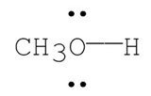
Answer:
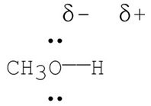
Section: 1-3
MCAT: 2.6

18) Covalent bonds may be polar or nonpolar. What property of the atoms forming a given bond determines this?
Answer: electronegativity
Section: 1-3
MCAT: 1.5

19) Provide the mathematical equation for the dipole moment of a bond, and identify the variables.
Answer: μ = e × d, where μ is the bond dipole moment, e is the amount of charge which is separated, and d is the distance over which the charge is separated.
Section: 1-3
MCAT: 1.5

20) The formal charge on nitrogen in the compound below is
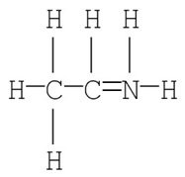
A) +2
B) +1
C) 0
D) -1
E) -2
Answer: B
Section: 1-4
MCAT: 1.2
21) Which of the following is the most likely electronic structure for C2H2?
A)
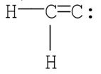
B)
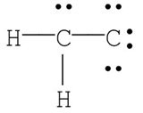
C)
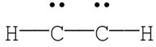
D) H—CC—H
E)
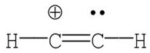
Answer: D
Section: 1-4
MCAT: 1.2, 2.1, 2.2

22) Which of the following structures, including formal charges, is correct for diazomethane, CH2N2?
A) : CH2—NN :
B)
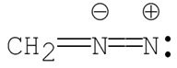
C)
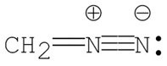
D)
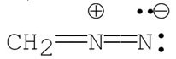
E)
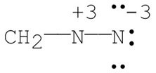
Answer: D
Section: 1-4
MCAT: 1.2, 2.1
23) What are the formal charges on nitrogen and the starred oxygen atom in the following molecule?
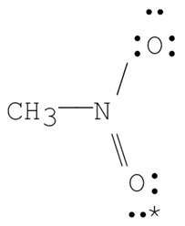
A) N = -1, O = 0
B) N = +1, O = -1
C) N = +1, O = +1
D) N = -1, O = -1
E) N= +1, O = 0
Answer: E
Section: 1-4
MCAT: 2.1

24) Draw the Kekulé structure for each of the following:
a. CH3CH2OH b. CH3CHO c. (CH3)3C+
Answer:
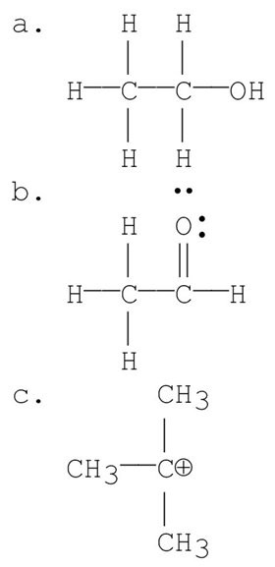
Section: 1-4
MCAT: 1.2, 2.1

25) The Kekulé structure of pentane is shown below. Draw the condensed structural formula which corresponds to this Lewis structure.
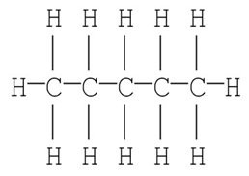
Answer: CH3(CH2)3CH3
Section: 1-4
26) Draw condensed structures for the four compounds with formula C3H9N.
Answer: CH3CH2CH2NH2
CH3CH2NHCH3
(CH3)2CHNH2
(CH3)3N
Section: 1-4
MCAT: 1.1
GLO: G2

27) Draw a Lewis structure for the molecule given and show all formal charges.
CH2CO
Answer:
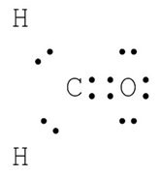
Section: 1-4
MCAT: 1.2, 2.1

28) Expand the condensed structure below to show the covalent bonds and the lone-pair electrons.
(CH3)2CHCH2CHO
Answer:
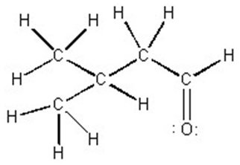
Section: 1-4
MCAT: 1.2, 2.1

29) Draw the Lewis structure for CH3N2+.
Answer:
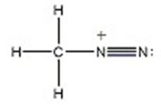
Section: 1-4
MCAT: 1.2, 2.1
30) Give the formal charge on nitrogen in NH4.
A) -2
B) -1
C) 0
D) +1
E) +2
Answer: D
Section: 1-4
MCAT: 1.2

31) How many distinct and degenerate p orbitals exist in the second electron shell, where n = 2?
A) 0
B) 1
C) 2
D) 3
E) 4
Answer: D
Section: 1-5

32) Draw the shape of a 2p orbital.
Answer:
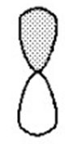
Section: 1-5

33) Consider the interaction of two hydrogen 1s atomic orbitals of the same phase. Which of the statements below is an incorrect description of this interaction?
A) A sigma bonding molecular orbital is formed.
B) The molecular orbital formed is lower in energy than a hydrogen 1s atomic orbital.
C) The molecular orbital formed has a node between the atoms.
D) The molecular orbital formed is cylindrically symmetric.
E) A maximum of two electrons may occupy the molecular orbital formed.
Answer: C
Section: 1-6

34) Both sigma (σ) and pi (π) bonds can be formed by overlapping p orbitals. Describe the difference.
Answer: Sigma bonds are formed from the overlap of atomic orbitals along a circular axis of symmetrical nature, i.e., head-on overlap. All single bonds are sigma bonds.

Pi bonds are formed from the overlap of atomic orbitals along a non-symmetrical (parallel) axis, i.e., side-to-side overlap. Double and triple bonds contain both sigma and pi bonds.
Section: 1-6
MCAT: 2.7, 7.5, 9.3, 14.3, 15.1
35) What kind of molecular orbital (σ, σ*, π, or π*) results when the two atomic orbitals shown below interact in the manner indicated?
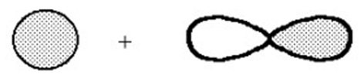
Answer: σ*
Section: 1-6
MCAT: 2.7, 7.5, 9.3, 14.3

36) What kind of molecular orbital (σ, σ*, π, or π*) results when the two atomic orbitals shown below interact in the manner indicated?
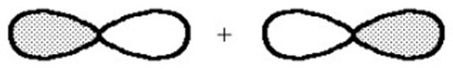
Answer: σ
Section: 1-6
MCAT: 2.7, 7.5, 9.3, 14.3

37) What kind of molecular orbital (σ, σ*, π, or π*) results when the two atomic orbitals shown below interact in the manner indicated?
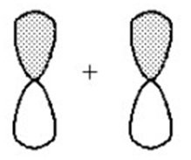
Answer: π
Section: 1-6
MCAT: 2.7, 7.5, 9.3, 14.3

38) What kind of molecular orbital (σ, σ*, π, or π*) results when the two atomic orbitals shown below interact in the manner indicated?
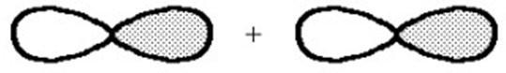
Answer: σ*
Section: 1-6
MCAT: 2.7, 7.5, 9.3, 14.3

39) What kind of molecular orbital (σ, σ*, π, or π*) results when the two atomic orbitals shown below interact in the manner indicated?
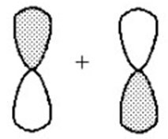
Answer: π*
Section: 1-6
MCAT: 2.7, 7.5, 9.3, 14.3
40) Choose the correct hybridization for the atom indicated in the molecule below.
CH3CH2CH2CH3
↑
A) sp
B) sp2
C) sp3
D) none of the above
Answer: C
Section: 1-7
MCAT: 2.2

41) What orbitals are used to form the covalent bonds in butane (CH3CH2CH2CH3)?
Answer: The carbon-carbon σ bonds are formed by the overlap of two carbon sp3 hybrid atomic orbitals. The carbon-hydrogen σ bonds are formed by the overlap of a carbon sp3 hybrid atomic orbital and a hydrogen s orbital.
Section: 1-7
MCAT: 2.7, 7.5, 9.3, 14.3
GLO: G2

42) How many carbon-carbon sigma bonds are in the molecule shown?
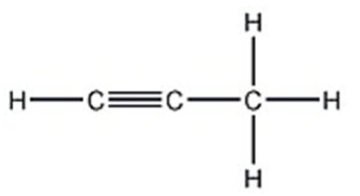
A) 1
B) 2
C) 3
D) 4
Answer: B
Section: 1-9
MCAT: 2.7, 7.5, 9.3, 14.3

43) A molecule of acetonitrile CH3CN contains ________ sigma bonds and ________ pi bonds.
A) 5, 2
B) 4, 3
C) 4, 2
D) 2, 2
E) 4, 0
Answer: A
Section: 1-9
MCAT: 2.7, 7.5, 9.3, 14.3
44) Which carbon(s) in the following molecule is (are) sp hybridized?
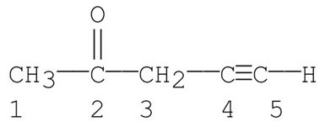
A) carbon 1
B) carbon 2
C) carbons 1, 3
D) carbons 4
E) carbons 4, 5
Answer: E
Section: 1-9
MCAT: 2.2

45) Determine the number of pi bonds in CH3CN.
A) 0
B) 1
C) 2
D) 3
E) 4
Answer: C
Section: 1-9
MCAT: 2.2, 2.7, 7.5, 9.3, 14.3

46) How many sp2 hybridized carbons are present in allene (H2C=C=CH2)?
A) 0
B) 1
C) 1.5
D) 2
E) 3
Answer: D
Section: 1-9
MCAT: 2.2

47) What orbitals overlap to create the C-H bond in ethene (H2C=CH2)?
A) s-sp
B) s-sp2
C) s-sp3
D) s-p
E) p-p
Answer: B
Section: 1-10
MCAT: 2.2, 2.7, 7.5, 9.3, 14.3
GLO: G2
48) Which of the following is an sp2 hybridized carbon?
A)
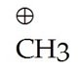
B) ∙ CH3
C)
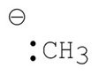
D) A and B
E) A, B and C
Answer: A
Section: 1-18
MCAT: 2.2, 4.2

49) What is the predicted shape, bond angle, and hybridization for +CH3?
A) trigonal planar, 120°, sp2
B) trigonal planar, 120°, sp3
C) trigonal planar, 109.5°, sp2
D) trigonal pyramidal, 120°, sp2
E) trigonal pyramidal, 109.5°, sp2
Answer: A
Section: 1-10
MCAT: 2.2

50) What orbitals overlap to create the H-C bond in CH3+?
A) sp3-sp3
B) sp2-sp3
C) s-p
D) s-sp2
E) s-sp3
Answer: D
Section: 1-10
MCAT: 4.2

51) The lone-pair electrons of the methyl anion occupy a(n) ________ orbital.
A) s
B) p
C) sp
D) sp2
E) sp3
Answer: E
Section: 1-10
MCAT: 2.2, 2.7, 7.5, 9.3, 14.3
52) Give the shape of the methyl radical.
A) trigonal pyramidal
B) tetrahedral
C) bent
D) linear
E) trigonal planar
Answer: E
Section: 1-10
MCAT: 2.2

53) The N-H single bond in methyl amine (CH3NH2) is a ________ bond formed by the overlap of a(n) ________ orbital on N and a(n) ________ orbital on H.
A) σ; sp2; s
B) σ ; sp3; s
C) π ; sp3; s
D) π ; sp2; p
E) π ; p ; p
Answer: B
Section: 1-11
MCAT: 2.2, 2.7, 7.5, 9.3, 14.3

54) Triethylamine [(CH3CH2)3N] is a molecule in which the nitrogen atom is ________ hybridized and the CNC bond angle is ________.
A) sp2, >109.5°
B) sp2, <109.5°
C) sp3, >109.5°
D) sp3, <109.5°
E) sp, 109.5°
Answer: D
Section: 1-11
MCAT: 2.2, 2.7, 7.5, 9.3, 14.3

55) The N-H bond in the ammonium ion, NH4+, is formed by the overlap of what two orbitals?
A) sp3-sp3
B) sp3-sp2
C) sp2-sp2
D) sp2-s
E) sp3-s
Answer: E
Section: 1-11
MCAT: 2.2, 2.7, 7.5, 9.3, 14.3
56) Which of the following is closest to the C-O-C bond angle in CH3-O-CH3?
A) 180°
B) 120°
C) 109.5°
D) 90°
E) 160°
Answer: C
Section: 1-14
MCAT: 2.2

57) Each lone pair of electrons on the O atom in methanol (CH3OH) occupies a(n) ________ orbital.
A) s
B) p
C) sp
D) sp2
E) sp3
Answer: E
Section: 1-12
MCAT: 2.2

58) Among the hydrogen halides, the strongest bond is found in ________ and the longest bond is found in ________.
A) HF, HF
B) HF, HI
C) HI, HF
D) HI, HI
E) HCl, HBr
Answer: B
Section: 1-13

59) The hydrogen-halogen bond becomes ________ and ________ as the size (atomic weight) of the halogen increases.
A) longer, weaker
B) longer, stronger
C) shorter, weaker
D) shorter, stronger
Answer: A
Section: 1-13
60) Which bond in the following molecule is the shortest?
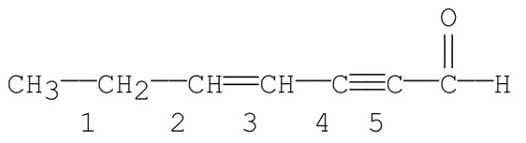
A) bond 1
B) bond 2
C) bond 3
D) bond 4
E) bond 5
Answer: E
Section: 1-15

61) Which of the following species have tetrahedral bond angles?
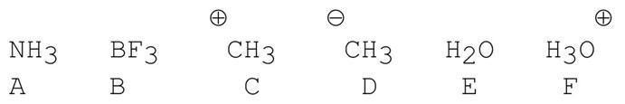
A) A, D and E
B) A, D, E and F
C) A and E
D) D only
E) A, B and E
Answer: B
Section: 1-14
MCAT: 2.2, 4.2

62) The carbon-carbon double bond in ethene is ________ and ________ than the carbon-carbon triple bond in ethyne.
A) stronger; shorter
B) stronger; longer
C) weaker; shorter
D) weaker; longer
E) stronger; more polar
Answer: D
Section: 1-15

63) What is the CNN bond angle in the compound shown below?
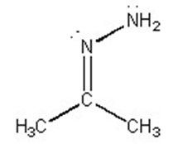
A) ~60°
B) ~90°
C) ~110°
D) ~120°
E) ~180°
Answer: D
Section: 1-14
MCAT: 2.2
64) Draw the structure of a molecule which contains only carbon and hydrogen atoms (only three of which are carbon) and in which two of the carbons are sp2 hybridized and the other is sp hybridized.
Answer: H2CCCH2
Section: 1-15
MCAT: 2.2, 2.7, 7.5, 9.3, 14.3
GLO: G2

65) Why is the C—H bond in ethene (H2CCH2) shorter and stronger than the C—H bond in ethane (CH3CH3)?
Answer: The length and strength of a C—H bond depends on the hybridization of the carbon atom. The more s character in the hybrid orbital used by carbon to form the bond, the shorter and stronger the bond. This is because an s orbital is closer to the nucleus than is a p. Ethene uses carbon sp2 hybrid orbitals (1/3 s character) to make its carbon-hydrogen bonds while ethane uses carbon sp3 (1/4 s character).
Section: 1-15
GLO: G2

66) How many nonbonding electron pairs, bonding electron pairs, pi bonds, and sigma bonds are present in CO2?
Answer: 4 nonbonding electron pairs, 4 bonding electrons pairs, 2 pi bonds, 2 sigma bonds
Section: 1-15

67) Identify the hybridization of carbon in H2CO.
A) sp
B) sp2
C) sp3
D) sp4
E) s3p
Answer: B
Section: 1-14
MCAT: 9.3

68) Give the H-C-H bond angle in H2CO.
A) 60
B) 90
C) 109.5
D) 120
E) 180
Answer: D
Section: 1-15
69) Identify the hybridization of the oxygen in CH3OCH3.
A) sp
B) sp2
C) sp3
D) sp4
E) sp5
Answer: C
Section: 1-15

70) Give the hybridizations of the carbons, from left to right, in CH3CHCHCl.
Answer: sp3, sp2, sp2
Section: 1-15

71) Give the hybridization, shape, and bond angle for the carbon in CO2.
Answer: sp, linear, 180
Section: 1-15

72) Give the hybridization, shape, and bond angle for each carbon in CH3CN.
Answer: CH3 - sp3, tetrahedral, 109.5; C - sp, linear, 180
Section: 1-14

73) Identify the compound with the weakest bond.
A) H2
B) HF
C) HCl
D) HBr
E) HI
Answer: E
Section: 1-15

74) Identify the hybridization of the nitrogen atom in the molecule (CH3)3N.
Answer: sp3
Section: 1-15
MCAT: 2.2

75) In what type of orbital are the lone pair electrons of methoxide (CH3O-) found ?
A) s
B) p
C) sp
D) sp2
E) sp3
Answer: E
Section: 1-15
MCAT: 2.2
GLO: G2
76) Which of the following molecules does not exhibit a net dipole moment of zero?
A) CO2
B) CH4
C) CCl4
D) H2O
E) SO3
Answer: D
Section: 1-16
MCAT: 2.6

77) Which of the following molecules has a net dipole moment of zero?
A)
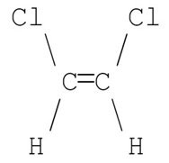
B)
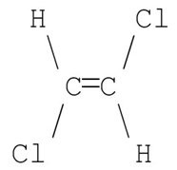
C)
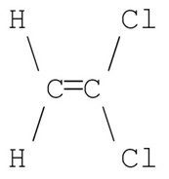
D)
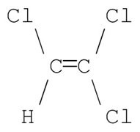
E)
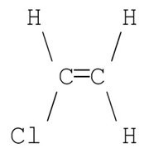
Answer: B
Section: 1-16
MCAT: 2.6
78) Which of the following molecules has the smallest dipole moment?
A) Br2
B) NH3
C) HCl
D) HBr
E) HI
Answer: A
Section: 1-16
MCAT: 2.5, 6.4
GLO: G2

79) BF3 has a dipole moment of zero. Propose a structure for BF3 that is consistent with this information.
Answer: BF3 is trigonal planar.
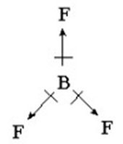
Section: 1-16
MCAT: 2.2, 2.5

80) Draw the Kekulé structure and show the direction of the dipole moment for CH2Cl2.
Answer: 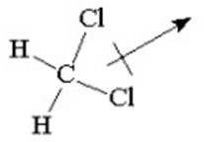
Section: 1-16
MCAT: 2.2, 2.5

81) Identify the compound(s) that have a nonzero dipole moment. You may choose more than one answer.
A) CH3NH2
B) CO2
C) CH3OCH3
D) (CH3)2CC(CH3)2
E) BCl3
Answer: A, C
Section: 1-16
MCAT: 2.2, 2.5
82) In 2015, the European Space Agency's Philae Lander detected the presence of methylisocyanate CH3NCO on the comet 67P. Draw the Lewis structure of this compound, showing all lone pairs.
Answer:
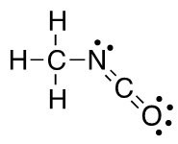
Section: 1-4
MCAT: 2.2

83) Convert the model below into skeletal structure.
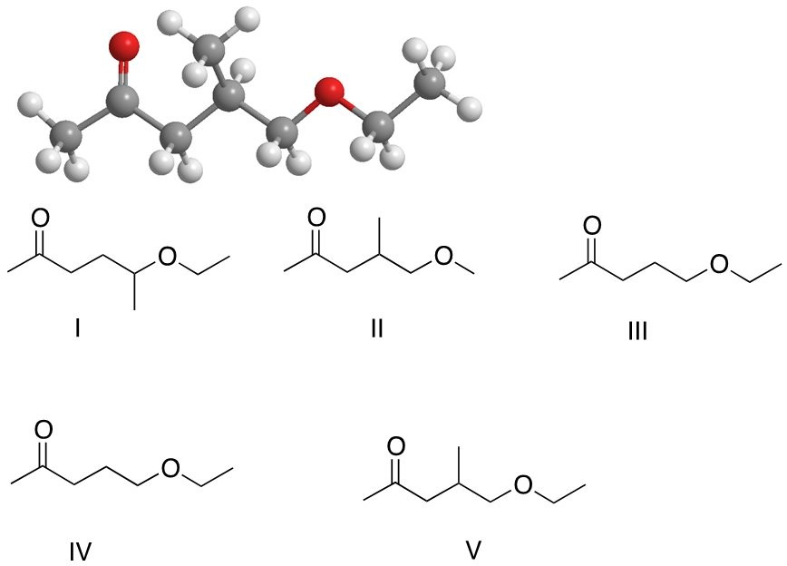
A) I
B) II
C) III
D) IV
E) V
Answer: E
Section: 1-4
84) Several volatile compounds are responsible for the aroma of plums. One of these compounds is γ-decalactone whose Kekulé structure is shown below. Convert it into a skeletal structure.
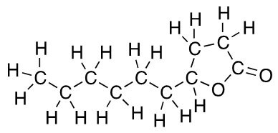
Answer:
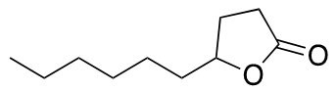
Section: 1-4
GLO: G7

85) Several volatile compounds are responsible for the aroma of plums. One of these compounds is linalool whose a skeletal structure is shown below. Convert it into Kekulé structure.
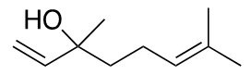
Answer:
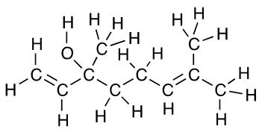
Section: 1-4
GLO: G7

86) Propanal is a compound detected on the surface of comet 67P by the Philae Lander. How many hydrogen atoms are present at the indicated carbon?
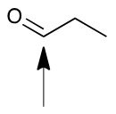
A) 0
B) 1
C) 2
D) 3
E) 4
Answer: B
Section: 1-4
MCAT: 2.2
87) Nitrous oxide N2O, also known as laughing gas is often used in surgery and dentistry for its anesthetic and analgesic effects. Draw its Lewis structure?
Answer:
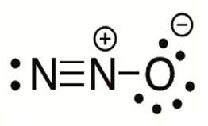
Section: 1-4
MCAT: 2.2
GLO: G7

88) The lobes of the p-orbital are often designated by "+" and "-" signs as shown. What do these signs represent?
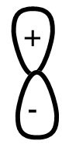
A) opposite charges
B) phases of the orbital
C) positive indicates the location of protons and negative indicates the location of electrons
D) that the orbital has polarity
E) all of the above
Answer: B
Section: 1-5

89) The structure of a widely used anesthetic propofol is given below. How many sp3 hybridized atoms are in this molecule?
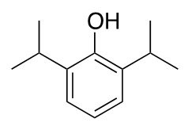
A) 1
B) 3
C) 5
D) 6
E) 9
Answer: D
Section: 1-15
MCAT: 2.2
90) Propanal is a compound detected on the surface of comet 67P by the Philae Lander. How many atoms sp2 hybridized atoms are in this molecule?
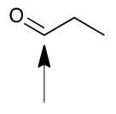
A) 0
B) 1
C) 2
D) 3
E) 4
Answer: C
Section: 1-15
MCAT: 2.2

